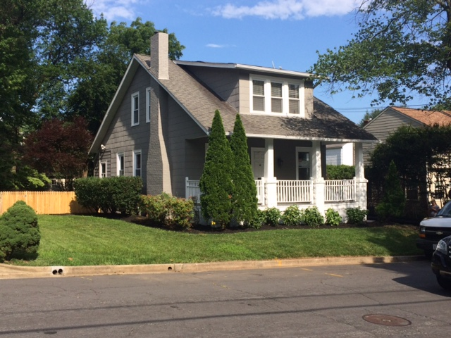
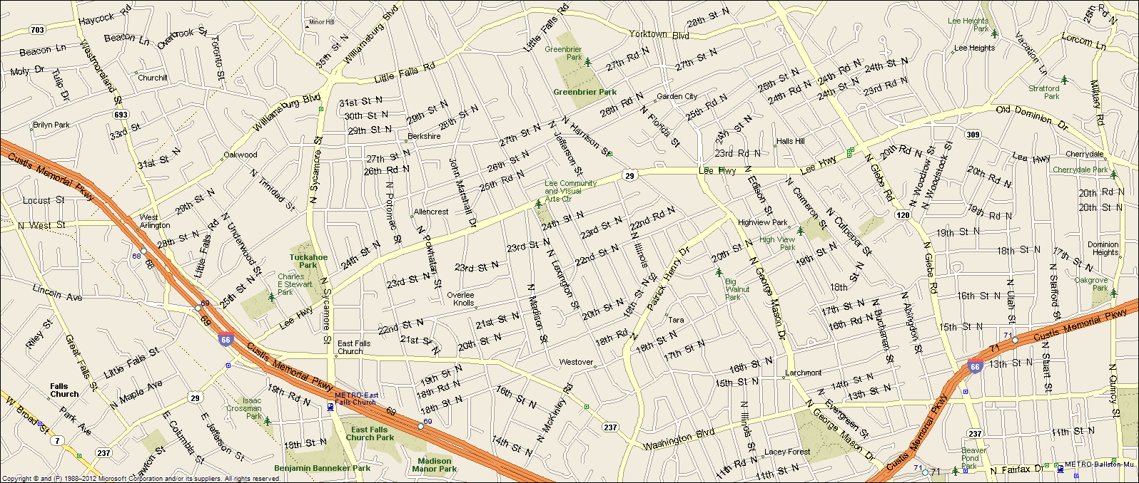2309 N Madison Street Arlington, VA 22205
Great location: Walk to EFC Metro & Westover Village & Library, District Taco, and the new Italian Deli, Close to DC (6 miles), Tyson’s Corner (6 miles), I-66, Rt. 29
- Four bedrooms, two full baths.
- All new kitchens, w/ GE Café appliance, new granite, new cabinets.
- Brand new bathroom on the main level.
- Central a/c, natural gas heat & hot water.
- Large landscaped yard, great back yard.
- Original hardwood floors thru out, recently refinished.
- Established quiet neighborhood.
- Excellent Schools: Tuckahoe Elementary, Swanson MS, & Yorktown HS
- Lease terms: 1 year minimum, no smoking, no use of fire place, no pets
RENT: $3750.00/ Month + utilities contact Lyndsay Saffer 7039063082
email: safferlyndsay@gmail.com

